MDTF Generic Terms of Reference

I. Introduction
This section provides background information on the context, opportunities, and challenges within which the establishment of the MDTF takes place, including references to key policy documents (such as government policy papers, Concept Note, One UN Programme, UNDAF, global or regional agreements, etc). It also includes a brief description of the rationale for the fund and linkage to any other related or relevant initiatives.
II. Functions of the [Name of MDTF]
This section details the fund function(s). The functions can evolve over time and can be combined and sequenced. Some fund functions listed below highlight the added value pooled funds typically provide:
Coherence: Most pooled funds will support policy coherence. In addition, some funds will emphasize programme coherence by filling critical gaps and supporting underfinanced priorities.
Consolidation: Reduces fragmentation with respect to particular priorities. In many cases, it is the largest investment vehicle.
Specialized or thematic: Has a specific expertise and focus on a particular thematic issue. Usually the case for global funds.
Risk management: Reduces risks to governments and financial contributors through a comprehensive risk and results-based management system.
Strengthening national systems: Uses and strengthens national systems.
Innovation: Provides a mechanism for clear attribution and transparency from innovative sources of finance.
III. Programmatic Scope and Theory of Change
This section explains the objectives and the scope of the fund, which are usually based on/anchored in an existing strategic framework (national, regional or global). It includes the fund strategy and the underlying theory of change (ToC). The fund strategy should articulate the approach for achieving the objectives.
The TOC describes the fund’s assumptions about the change that is needed and the strategies required tobring about the desired change. It provides a critical change path for validating the causal relationships between the goals, impacts, outcomes and outputs.
The strategy will be translated into a set of concrete expected fund results:
- Fund impacts or goals: the long-term changes in people’s lives produced by an intervention, directly or indirectly and intended or unintended. This might include changes in behavior, health or living conditions.
- Fund outcomes: usually changes in institutional or behavioral capacities that occur following the completion of outputs.
- Indicative Fund outputs: usually the availability of new products and services that are achieved with the resources provided within the time period specified. Outputs are defined at project level so these fund outputs will be just indicative.
A fund results matrix with indicators, including baseline, targets, means of verification and data collection methods should be developed and attached as an annex.
IV. Governance Arrangements
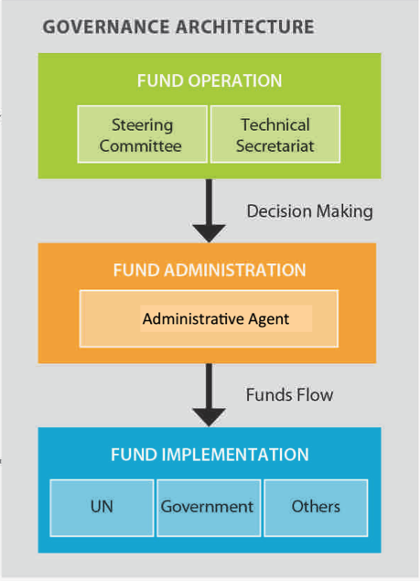
This section describes the governance arrangements of the MDTF, with sub-sections on the governance bodies for each of the fund management functions (fund operation, fund administration and fund implementation). It may also include a diagram illustrating the governance arrangements (see example). The governance architecture is usually comprised of the following bodies:
MDTF Steering Committee or similar governance mechanism
Description of the MDTF Steering Committee, building on the UNDG Generic Terms of Reference for Steering Committees, including its responsibilities and composition; ideally membership in the Steering Committee will not exceed 9 members, and composition will vary depending on the scope and purpose of the fund. The Administrative Agent is always an ex officio member of the Steering Committee. In case of large funds, a tiered governance structure might be considered that splits the main functions between two bodies. Or alternatively membership can be on a rotational basis within each major stakeholder group (e.g. contributors, PUNOs, civil society, ministries, etc.). Rules of procedure should be developed, particularly with regards to participation and decision-making (e.g. quorum, chairing arrangements, consensus decisions).
Detailed main functions:
- Provide general oversight and exercising overall accountability of the Fund;
- Approve the strategic direction of the Fund and its overall results framework;
- Approve Fund risk management strategy and review risk monitoring regularly;
- Review and approve proposals submitted for funding (if applicable: after being cleared by the relevant thematic working groups), ensuring their conformity with the requirements of the Fund Terms of Reference (TOR);
- Decide the allocation of funds;
- Request fund transfers to the Administrative Agent (signed off by UN member of the Steering Committee);
- Review Fund status and oversee the overall progress against the results framework through monitoring, reporting and evaluation;
- Review and approve the periodic progress reports consolidated by the Administrative Agent and the Secretariat based on the progress reports submitted by the Implementing Entities;
- Commission mid-term and final independent evaluations on the overall performance of the Fund;
- Approve direct costs related to fund operations supported by the Secretariat;
- Approve Fund extensions and updates to the Fund TOR, as required.
- Develop and implement resource mobilization strategies to capitalize the Fund.

Secretariat
Description of the roles and responsibilities of the MDTF Secretariat. Typically this is the entity responsible for the programmatic coordination and monitoring of the Fund. The unit is usually embedded (e.g. RCO, relevant ministry, regional office) and provides technical and management support. The Secretariat is normally hosted by one of the Participating UN Organisations. As per the MDTF MOU/SAA, the costs of such support may be charged as direct costs to the MDTF with the approval of the Steering Committee. The budget is agreed and approved annually by the Steering Committee, and would normally not exceed 3%.
The Secretariat is responsible for:
- Advise the Steering Committee on strategic priorities, programmatic and financial allocations (based on the inputs of inter-agency working groups and the Administrative Agent, if applicable)
- Provide logistical and operational support to the Steering Committee;
- Organize calls for proposals and appraisal processes;
- Ensure the monitoring of the operational risks and Fund performance;
- Consolidate annual and final narrative reports provided by the Participating UN Organisations and share with the Steering Committee for review as well as with Administrative Agent for preparation of consolidated narrative and financial reports;
- Facilitate collaboration and communication between Participating UN Organizations to ensure programmes are implemented effectively.
- Liaise with the Administrative Agent on fund administration issues, including issues related to project/ fund extensions and project/fund closure.

The Administrative Agent
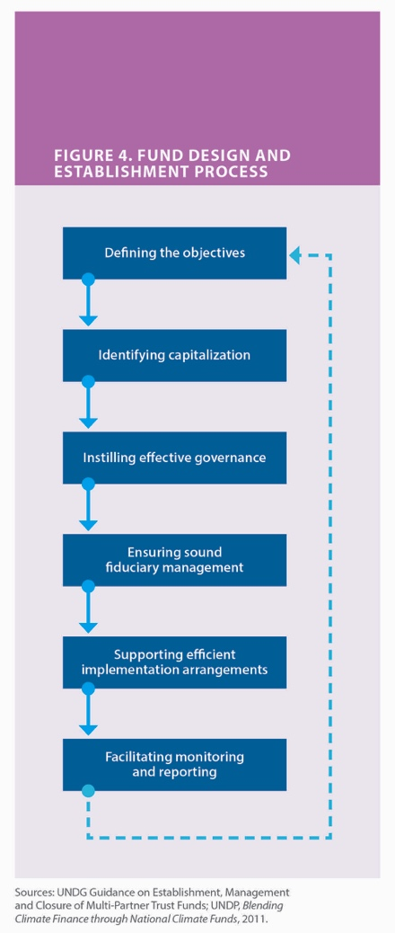
Description of the responsibilities of the Administrative Agent, as per UNDG “Protocol on the Administrative Agent for Multi-Donor Trust Funds and Joint Programmes, and One UN Funds”. Where a UN organization is both an AA and a Participating UN Organization, reference to the delineation of roles and responsibilities between the AA function and the implementation function should be made. The AA will be entitled to allocate an administrative fee of one percent (1%) of the amount contributed by each donor, to meet the costs of performing the AA’s standard functions as described in the MOU.
The standard functions include:
- Fund design: Support for developing the Fund concept note and the TOR. This includes notably support for the design of the fund architecture (i.e. governance arrangements), the preparation of the legal instruments based on standard legal agreements, and the development of a logical framework based on the theory of change
- Fund administration: The Administrative Agent will conclude a Memorandum of Understanding (MOU) with the Participating UN Organisations and Standard Administrative Arrangements (SAAs) with contributing partners. Receipt, administration, and disbursement of funds to the participating organizations according to the instructions of the Steering Committee, financial reporting and consolidation. The Administrative Agent will disburse funds to the Secretariat for direct costs based on the decision of the Steering Committee. On an annual basis, the Administrative Agent will notify the Steering Committee of the amounts used for such purposes.
The Participating UN Organisations
Role of PUNO should be explained, including standard language on accepting full financial and programmatic accountability for their programmes; reference to UN values, norms and standards and subsequent need to apply programmatic safeguards (e.g. social & environmental screening).

V. Fund Implementation
In many MDTFs, fund implementation is limited to UN organisations. However, a UNDG MDTF can also be designed as part of a multi-window set-up, with several windows of implementation. This architecture enables the various stakeholders to operate under a common strategic governance structure, but according to their individual policies and procedures
In addition to a United Nations window (with funding allocated to UN Agencies and non-UN entities having concluded the separate MOU for Non-UN Participating Organizations), a Fund could also include a government window, an IFI window (or windows), a civil society window (with one of the UN agencies appointed as the Management Agent with programmatic and financial accountability for funding channeled to NGOs), and/or an international cooperation agencies window.
Project Approval Cycle
This section elaborates on the process for the approval of projects submitted for funding by eligible fund implementers, as defined in the fund implementation section. Typical steps in the project approval cycle are submission, independent review/assessment, and fund allocation, which depending on the size and complexity of the Fund can comprise several steps. Depending on need, a “regular cycle” (usually with explicit approval) or “fast-track cycle” (non-objection basis) can be established. A portfolio approach instead of individual projects being submitted can be also considered.
Risk Management
MDTFs implicitly represent an element of risk sharing among all stakeholders, can assist in establishing a common understanding of risks, and can provide more efficiently and strategically for risk mitigation and adaptation measures. Risk sharing is a key element of the due diligence and operationalization of the fund, and it is understood that the residual risk is shared among all stakeholders.
Three types of risks – contextual, programmatic, and institutional – should be considered and provisions for the identification, monitoring, tolerances, and risk responses should be considered and vested as part of the fund risk management strategy. Allocation criteria, including thematic priorities and project partner selection criteria, should reflect the fund’s risk management strategy in order to accelerate delivery and increase fund impact, and to ensure that fund operations ‘do no harm’ and are used for their intended purpose.

Figure 3: Risk ranking matrix (sample to be adjusted)
 |  | Consequences
 |  | Insignificant (1) | Minor (2) | Moderate (3) | Major (4) | Extreme (5)
Likelihood | Very Likely (5) | Medium  (5) | High  (10) | High  (15) | Very High  (20) | Very High  (25)
Likelihood | Likely (4) | Medium  (4) | Medium  (8) | High  (12) | High  (16) | Very High  (20)
Likelihood | Possible (3) | Low  (3) | Medium  (6) | High  (9) | High  (12) | High  (15)
Likelihood | Unlikely (2) | Low  (2) | Low  (4) | Medium  (6) | Medium  (8) | High  (10)
Likelihood | Rare (1) | Low  (1) | Low  (2) | Medium  (3) | Medium  (4) | High  (5)

A risk ranking matrix would capture the hierarchy of risk at different levels, allowing an assessment of the most appropriate responses to the identified risks, particularly to those risks most likely to impede success (very high and high).
Accountability
The provisions are specified in the legal instruments governing the Fund (MOU, MOA and SAA), and ensure a clear understanding with regards to programmatic and financial accountability of all stakeholders in the course of implementation. In addition to specifying the applicable rules and procedures this section can provide for any special arrangements in case the fund includes windows for non-UN stakeholders.

VI. Reporting
This section outlines the reporting arrangements for the Fund. For each project the implementing organization will provide the SC Support Office/Technical Secretariat and the Administrative Agent with annual and final reports and financial statements prepared in accordance with their accounting and reporting procedures in line with standard UNDG MOU/SAA. If any interim reporting is required then this should be noted as the responsibility of the Technical Secretariat
Typically the annual and final reports will be results-oriented and evidence based, and will give a summary of results and achievements compared to the goals and objectives of the approved result matrix in the programme document aligned with the fund result matrix.
Both programmatic and financial performance indicators will be monitored at the outcome and output level (fund and project level). Every project would monitor the key outcome indicators of the Fund to which it must contributes in accordance with the Fund Result Matrix. The output indicators would be specific to each project.
The prime responsibility for collecting data lies with the implementing organisations and will be one of the key elements reflected in their annual report. The SC Support Office/Technical Secretariat will be responsible for coordinating the data collection and ensuring the proper use of the reporting format.
The final report will also contain an analysis of how the outcomes and outputs have contributed to the overall impact.

VII. Monitoring and Evaluation
This section describes the monitoring and evaluation arrangements of the MDTF, in line with standard UNDG MOU/SAA. An annual meeting with all stakeholders should be provided for to review progress, and discuss significant changes in circumstances and major risks, and if needed substantive revisions to the TOR. The evaluation of the performance of each indicator will take external factors into account as well as the pre-identified assumptions and risks.

VIII. Audit
This section refers to the audit provisions in the standard MOU and SAA, as well as 2014 Framework for Joint Internal Audit of UN Joint Activities. The administrative agent and participating UN organizations will be audited according to their own rules and financial regulations and in line with this framework for joint audit. Government entities will be audited in accordance with the national audit framework.

IX. Public Disclosure
This section outlines the provisions related to transparency, visibility and public dissemination, which support the coherence function of the Fund. This includes how information on contributions, allocations and expenditures are communicated to stakeholders and the public (e.g. Gateway in case of MPTFO).
The Secretariat and the Administrative Agent ensure that the Fund's operations are disseminated, including SC decisions, project submissions and any other documents on work planning, fundraising or results assessment.
All stakeholders should take appropriate measures to promote the Fund. Information shared with the press regarding fund beneficiaries, official notices, reports and publications shall acknowledge the Fund role. More specifically, the Administrative Agent shall ensure that the role of the contributors and relevant stakeholders is fully acknowledged in all external communications related to the Fund.

X. Modification and Expiration of the MDTF
This section includes the provisions related to modification and/or expiration of the MDTF as per standard UNDG MOU/SAA. This may include a graphic representation of the life cycle of the Fund, including a time line that reflects the tentative dates for (a) approving the last fund allocations, (b) completion of all programmatic activities (= End Date) (c) the dissemination of the final narrative report, (d) the final financial closure of all agencies projects; (e) the financial closure of the Fund; and (f) the dissemination of the final financial report and certified financial statement.

These generic Terms of References are for use in Multi-Donor Trust Funds, including One UN Funds. Examples of existing MDTF Terms of References are available on mptf.undp.org and www.undg.org
The MPTF Office Manual on Designing Pooled Funds for Performance, June 2015, prepared under the auspices of the UN Working Group on Transition, contains further guidance on assessing the feasibility and functions of UN pooled funds.
The UNDG RBM Handbook, October 2011, contains guidance on theories of change and general RBM principles
“Project” refers to an approved programmatic document, as per MOU, which can be “an annual work plan or a programme/project document, etc., which is approved by the Steering Committee for fund allocation purposes.”
See UNDG programme risk management for pooled funding solutions in conflict and transition countries, May 2015

