Approval of 2018 UNCT Goals, UNCT Success Criteria and RC Indicators
FOR REGIONAL ARC ADMINISTRATOR

Approval of 2018 UNCT Goals, UNCT Success Criteria and RC Indicators

Introduction

The Regional UNSDG Performance Management Team has met to review the UNCT Goals, UNCT Success Criteria and RC Indicators for every UNCT in their respective regions. Until this point the approval process of the UNCT Goals, UNCT Success Criteria and RC Indicators has been paper based and taken place offline.

Once the Regional UNSDG Chair has approved the UNCT Goals, UNCT Success Criteria & RC Indicators in consultation with the Regional UNSDG Performance Management Team, the Regional ARC Administrator, on behalf of the Regional UNSDG Chair, will be able to approve them in the ARC platform.

This training guide shows how the Regional ARC Administrator, on behalf of the UNSDG Regional Chair, will approve the UNCT Goals, UNCT Success Criteria and RC Indicators in the ARC platform.

Accessing the ARC
Introduction
- To access the ARC go to www.undg.org/leadership/arc/. Please utilize Chrome or Firefox internet browsers to access the ARC platform. The new internet browser Edge is currently incompatible with the ARC platform.

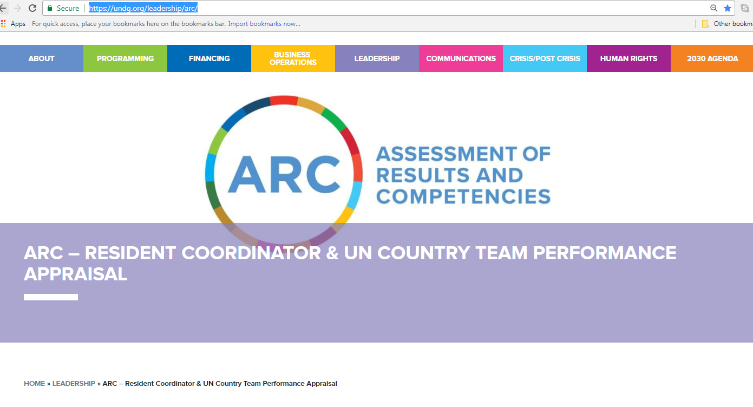
The ARC webpage will link you to the ARC login page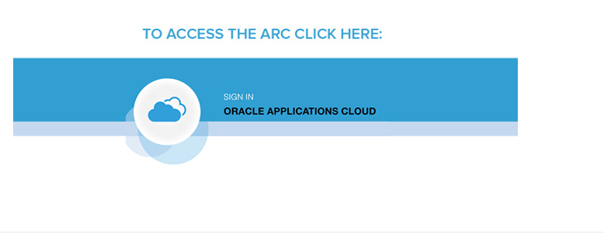

- Enter your (in this case it is the Regional ARC Administrator) username and password for the ARC system.

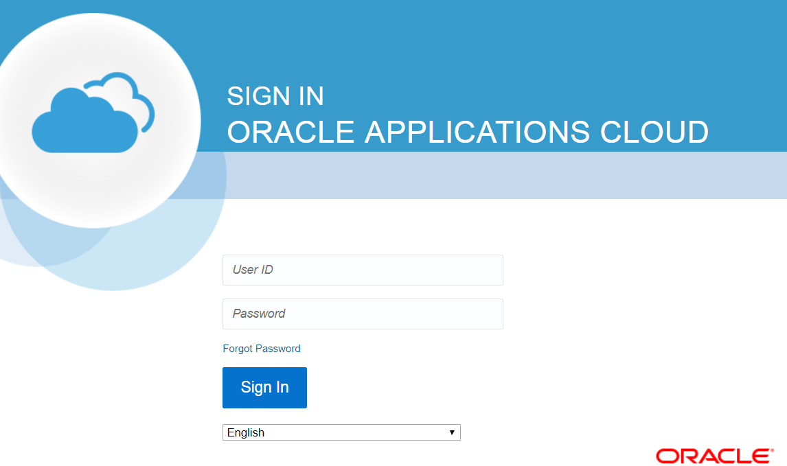

- Then, click Sign In.
    - This action opens the ARC home page unique to the Regional ARC Administrator.
    - The page contains information and links that are specific to your privileges in the ARC system.
    - The privileges in the ARC depend on your job function.

- Click on the bell icon to access the notifications.

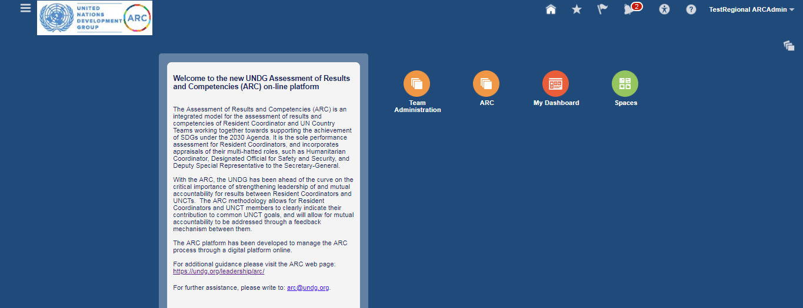

- Click on the hyperlink Action Required: UNCT1 ARCAdmin Requires Your Approval for the Goal Plan UNCT Goals – CT2_2018.

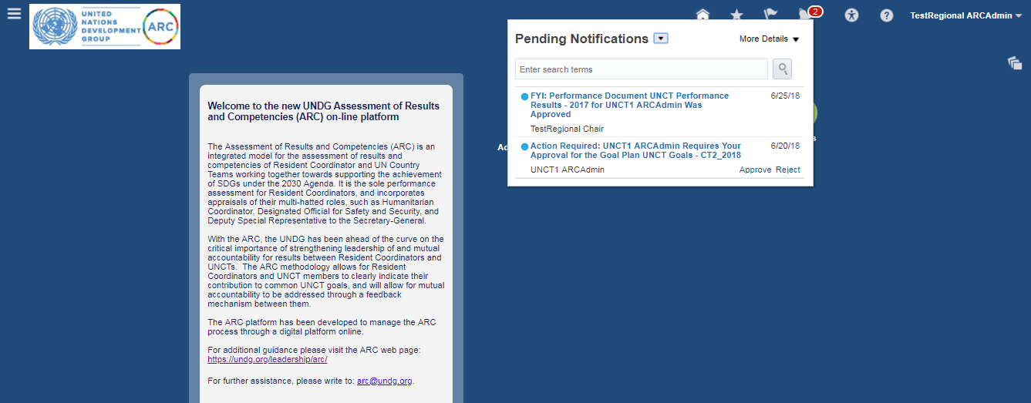

- The Approve Goals page will open. Review each of the 5 Goals and click Approve for each Goal.
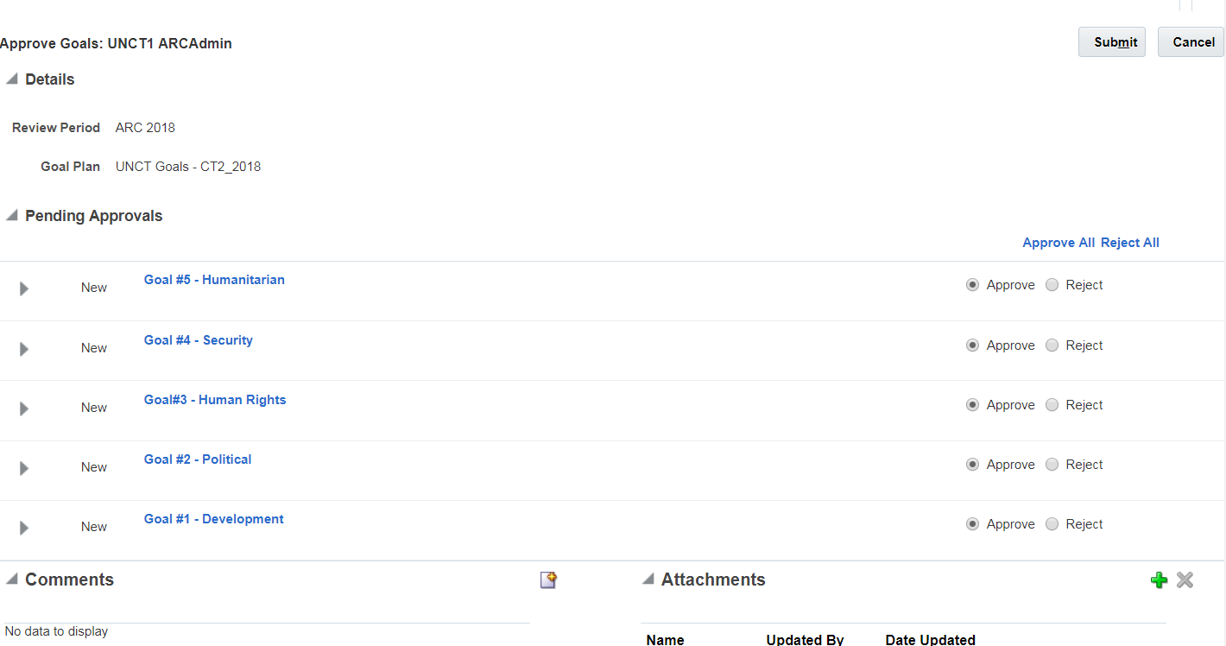

- Click Submit once all Goals are approved or rejected.
- You will return to the home page.

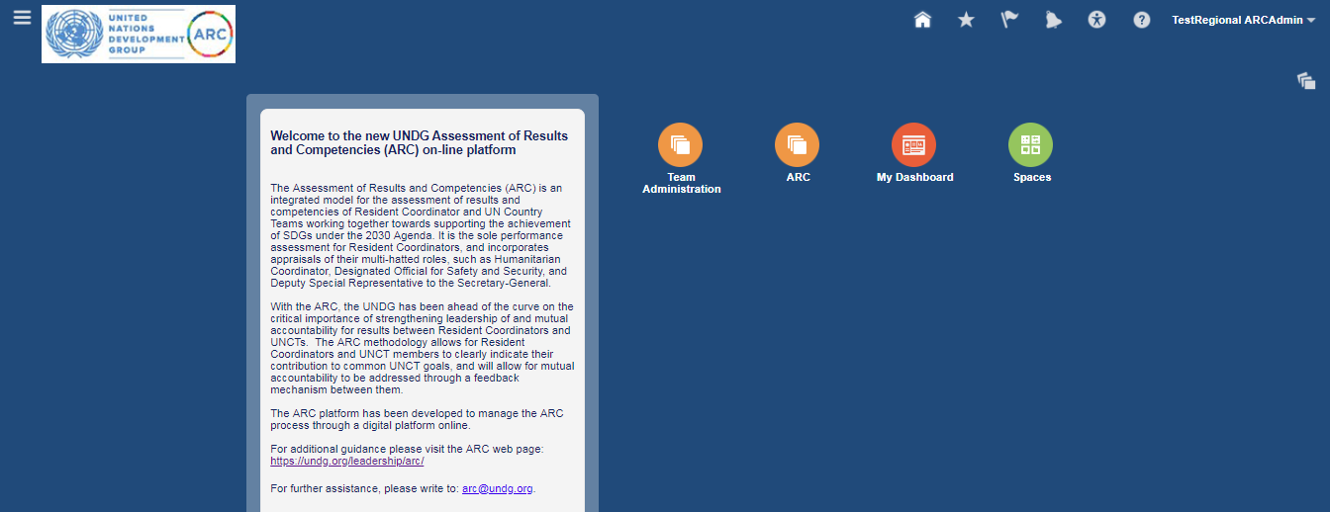

- To sign out click triangle button in top right hand corner and click SIGN OUT.
